

Enterprise Storage

**Runbook – NetApp 7 Mode Transition Tool**

**Synopsis:** This run book will cover utilizing NetApp’s 7 Mode Transition Tool to facilitate migrations between existing 7Mode systems and cDOT.

**Segment:** DCE

**Authors:** [David Ellis]

**Contributors:** [Contributors]

**Document Version:** [V0.1]

**Date:** [10/29/2014]

**Document Status**: [Draft]

Document Location: [DCO Storage Wiki](https://theshare.thomsonreuters.com/sites/AI/storwiki/_layouts/WordViewer.aspx?id=/sites/AI/storwiki/Shared%20Documents/Projects/ClusterMode/8040%20OR%20Docs/Runbook%207MTT.docx&Source=https%3A%2F%2Ftheshare%2Ethomsonreuters%2Ecom%2Fsites%2FAI%2Fstorwiki%2FShared%2520Documents%2FForms%2FAllItems%2Easpx%3FRootFolder%3D%252Fsites%252FAI%252Fstorwiki%252FShared%2520Documents%252FProjects%252FClusterMode%252F8040%2520OR%2520Docs%26InitialTabId%3DRibbon%252EDocument%26VisibilityContext%3DWSSTabPersistence&DefaultItemOpen=1&DefaultItemOpen=1)

**CONFIDENTIAL INFORMATION**

This document contains information proprietary to Thomson Reuters and may not be reproduced, disclosed or used in whole or part without express permission of Thomson Reuters.

© Thomson Reuters 2014

Contents

1 Introduction 3

1.1 Management Summary 3

1.2 Assumptions 3

1.3 Document References [Change below as appropriate] 3

1.4 Change History 3

1.5 Distribution List 3

1.6 Glossary 3

2 Limitations of 7 Mode Transition Tool 4

2.1 Volume Limitations 4

2.2 Configuration Limitations 4

2.3 Limits for Transition 5

3 Resources Used For Migration 6

3.1 Explanation of Transition Process 6

4 Migration Preparation 7

4.1 Add 7 Mode and Clustered Data ONTAP systems to tool 7

4.2 Name Project 7

4.3 Select Volume(s) for Transitioning 8

4.4 Migration Pre-Checks 9

4.5 SVM Mapping 9

4.6 Volume Mapping 10

4.7 Interface Mapping 10

4.8 Data Copy Schedule 11

4.9 Final Prechecks 12

4.10 Subproject Summary 13

5 Migration Activity 14

5.1 Start Baseline 14

5.2 Apply Configuration 14

5.3 Complete Transition 15

6 Post Migration Activity 17

6.1 Checks 17

# Introduction

## Management Summary

This document is created with the intention TR will be utilizing the NetApp 7 Mode Transition Tool to aide in moving volumes between the 7 Mode and cDOT platforms. The tool has many features, however only those relevant to the TR environment will be covered in this document. As additional features are deemed necessary to the migration process, they should be captured and documented. This document will cover each phase of the migration process including post migration steps necessary to adjust the new cDOT volumes to TR standards.

## Assumptions

It is assumed the audience is conversant with Netapp cDOT and 7Mode platforms. Also the user should have installed or be utilizing an installed instance of the 7MTT. The tool can be downloaded from the [NetApp Now Site](http://mysupport.netapp.com/NOW/download/software/ntap_7mtt/1.4/). Version 1.4 was utilized at the time this document was created.

## Document References [Change below as appropriate]

|  |  |  |  |  |
| --- | --- | --- | --- | --- |
|  | **Document Name and URL** | **Version** | **Date** | **Author** |
|  | [7-Mode Transition Tool Guide](https://127.0.0.1:8443/transition/docs/Clustered_Data_ONTAP_82_Data_and_Configuration_Transition_Guide.pdf) |  |  | NetApp |

## Change History

|  |  |  |  |
| --- | --- | --- | --- |
| **Ver** | **Date** | **Author** | **Key Changes** |
| 0.1 | 10/29/2014 | David Ellis | [First Draft] |
|  |  |  |  |
|  |  |  |  |
|  |  |  |  |

## Distribution List

|  |  |
| --- | --- |
| **Name** | **Role** |
| DCO-CPS-STO-DE-NAS | CPS NAS Design and Engineering Team |
| DCO-CPS-STO-DE-INT | CIS NAS Design and Engineering Team |
| Kevin Atkins | Lead OR Storage Engineer |
|  |  |
|  |  |
|  |  |
|  |  |

## Glossary

|  |  |
| --- | --- |
| **Term** | **Definition** |
| Project | A Project enables administrator to configure and manage the transition of a group of volumes |
| SubProject | A Subproject is a container within a project that groups a set of volumes for a transition. It also contains configuration details that are required for the transition. |
| Stand-alone subproject | Volumes in this subproject are not in a snapmiror relationship with volumes in other storage systems. |
|  |  |

# Limitations of 7 Mode Transition Tool

The tool is not without its limitations, most of these limitations exist as some of the features available in 7 Mode are not available on the cDOT platform.

## Volume Limitations

* Volumes with LUNs and LUN clones
* Restricted or offline volumes
* Traditional volumes
* Volumes with NFS-to-CIFS character mapping
* Volumes with Storage-Level Access Guard configurations
* SnapLock Volumes
* FlexCache Volumes
* 7 Mode volumes in a 64 bit aggreagate to a 32 bit aggregate in cDOT
* Flex Clone volumes can only be transistioned as FlexVol Volumes, however heirachy and starage efficiency will be lost
* Root volume on a vfiler root
* SnapLock volumes.

## Configuration Limitations

* IPv6 configurations
* Snapvault Relationships

Snapvault source volumes can be migrated however the SnapVault relationship must be broken first. Snapvault destinations cannot be migrated.

* FPolicy configurations
* BranchCache configurations
* Antivirus configurations
* FCoE configurations
* PC-NFS
* WebNFS
* NFSv2
* FTP
* Sub-Volume NFS exports other than qtree –level NFS exports

Transistion of qtree-level NFS exports is supported if the target cluster is running Data 8.2.1 and later.

* Fencing of NFS clients
* Transistion of volumes serving CIFS data that is being accessed by local users and groups to a Data ONTAP 8.2 destination cluster

Tool supports transistion of local users and groups only to clustered Data ONTAP 8.2.1 and later.

* CIFS NT4 Authentication
* CIFS NetBIOS aliases
* CIFS share-level ACLs with UNIX-style permissions
* Synchronous SnapMirror
* Qtree SnapMirror Relationships
* MetroClusster configurations
* Disaster recover vfiler unit
* NDMP configurations
* SFTP server
* TFTP server
* GARP VLAN Registration Protocol
* NIS for hos name lookup
* Settings in the /etc/host.equiv file

## Limits for Transition

Transition limitations are also inclusive of the numbers of controllers and hosts that can be accessed simultaneously. The administrator should be sure to monitor the number of volumes in a subproject and the number of subprojects that can executed simultaneously.

|  |  |
| --- | --- |
| Parameter | Maximum Limit |
| Number of Controllers | 4 |
| Number of hosts | 20 |
| Number of volumes in subproject | 160 |
| Recommend for total number of volumes across active subprojects | 240 |
| Maximum number of projects | 8 |

# Resources Used For Migration

|  |  |  |  |
| --- | --- | --- | --- |
| Source Information | | | |
| Controller | Vfiler | Volume | Size |
| eg-nastest-e09/10.220.30.57 | Orlab-test-e0001 | infra_test_7MTT_nosnap | 20G |

|  |  |  |  |
| --- | --- | --- | --- |
| Destination Information | | | |
| Node | VServer | Volume | Size |
| eag-nasor-clus1-8040HT-01/10.220.194.43 | Orprod-e0001 | cb0000_infra_test_7MTT_nosnap | 20G |

## Explanation of Transition Process

* Preparation - In this phase, the administrator uses the tool to select the system,cluster,volumes and IP addresses. Projects and subsequent subprojects are also created in advance of the prechecks being run.
* Data Copy - This phase copies the data from the 7-Mode system to cDOT. This is where the cDOT volumes are created as well as the transition peer relationships.
* Precutover Phase -This is where the configuration is transitioned. There are two modes, R\O and R\W. The R\W mode allows for the administrator to test the configuration before performing the final cutover.
* Storage Cutover – This is where the 7-Mode volume final update to cDOT is performed. The 7 mode volumes are also offlined and made inaccessible.
* Postwork- Volumes on the SVM are onlined, this is where the administrator will need to make adjustments to make sure the volume is in compliance with TR standards.

# Migration Preparation

## Add 7 Mode and Clustered Data ONTAP systems to tool

Enter Hostname, username, and password into appropriate fields, click add.

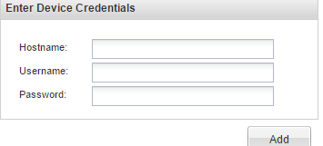

System will add device to appropriate Category within the tool

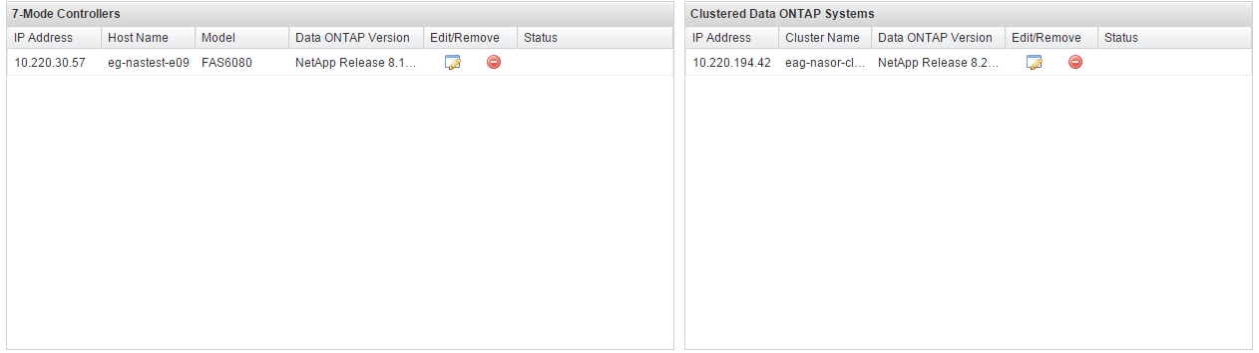

Click Next

## Name Project

Enter Project name into field, field cannot contain special charchters or spaces.

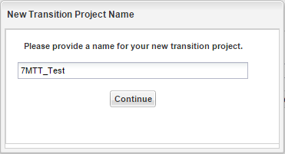

System will import 7 Mode system details into the tool.

## Select Volume(s) for Transitioning

In the tree, on the left, select vfiler(s) which contain those volume(s) will be migrating to CDOT system.

There are two available options when selecting the volume, transition as stand-alone, and transition with snap mirror relationship. Currently evaluating the use case for transitioning volumes with snap mirror relationship, if deemed necessary, all pertinent information will be added to this document.

In the center section select the appropriate volume by placing a checkmark in the option box, transition as a stand-alone. The volume information including name, size, and utilization will populate in the box below. Select additional volumes as needed.

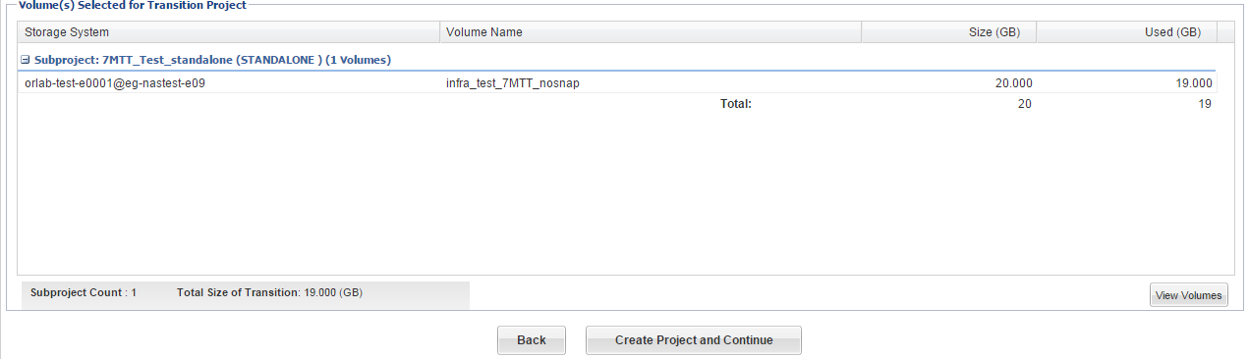

Next, select create project and continue.

The tool then creates a subproject, editable, as well as compiles all of the origin information. There is a field for multipath ip which is blank, entering another ip address here will enable the system to load balance the data transfers over more than one physical path.

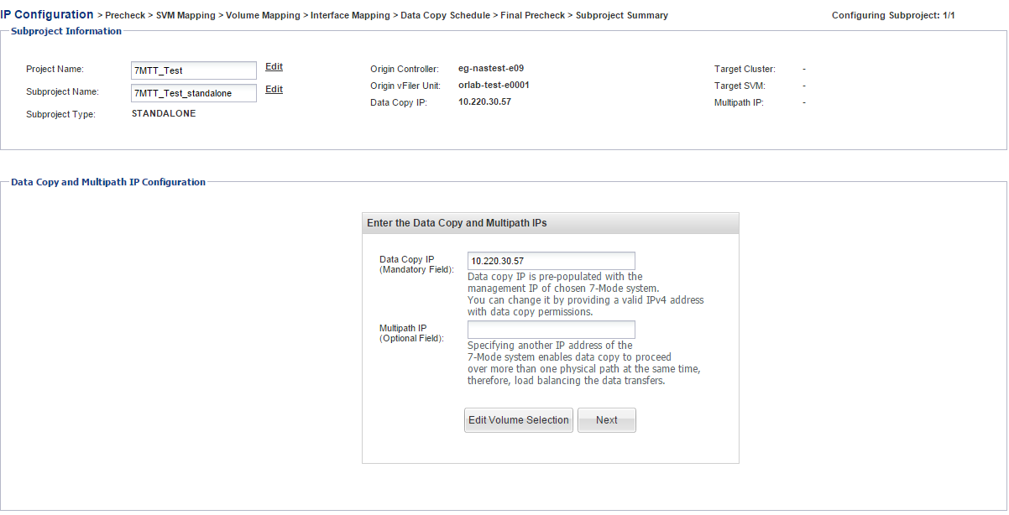

Select Next to continue.

## Migration Pre-Checks

The 7MTT performs a number of prechecks to determine if the migration will be successful. Click Run Prechecks to execute and obtain report.

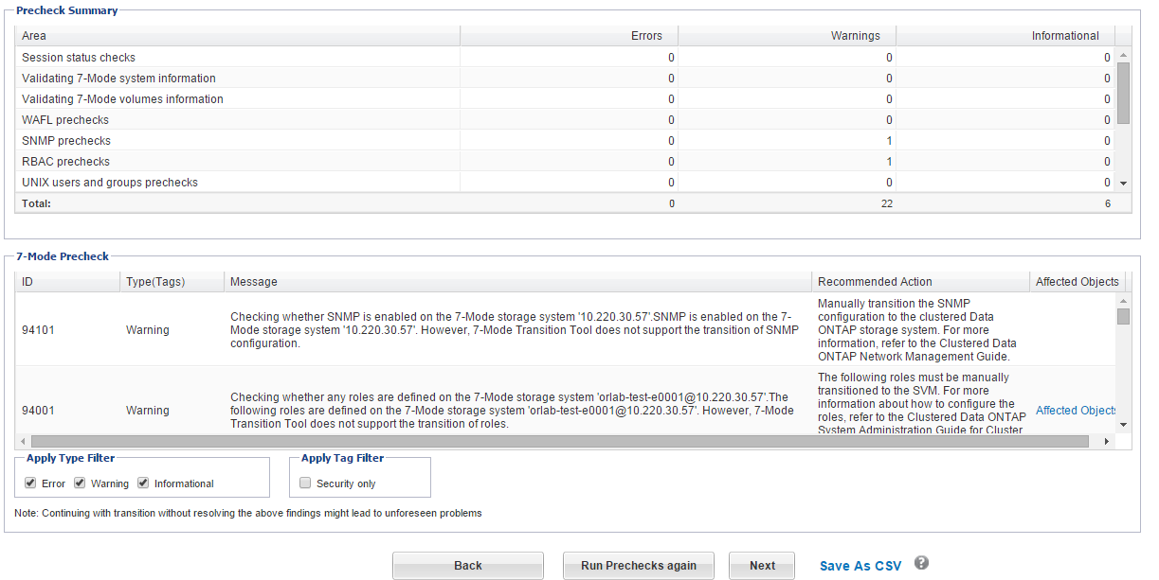

The Report return will return 3 categories of information.

1. Error- Configurations that cannot be transitioned and need to be fixed prior to migration. A popular error is offline volumes.
2. Warning – Configurations that can cause minor problems after transition. The migration can continue with these warnings however some configurations might be lost.
3. Information – Configurations that can be successfully transitioned.

Click Next to continue

## SVM Mapping

The 7MTT gives the administrator the ability to select desired CDOT Systems and SVM 7 mode volume should be migrated.

On the left select the desired cluster system, on the right select the desired SVM target. Click Next.

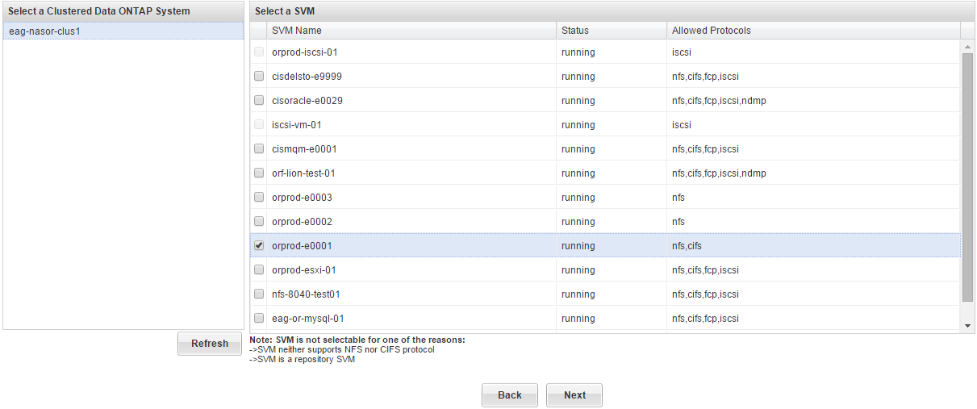

## Volume Mapping

The next step is to define the volume parameters within the cDOT architecture. The administrator needs to define both the Target Aggregate and the target volume. The new volume name should align with existing [cDOT naming standards](https://theshare.thomsonreuters.com/sites/AI/storwiki/_layouts/WordViewer.aspx?id=/sites/AI/storwiki/Shared%20Documents/NetApp_Std_Preso/Engineering%20Standards/C-DOT/C-mode_namings_v0%208.docx&Source=https%3A%2F%2Ftheshare%2Ethomsonreuters%2Ecom%2Fsites%2FAI%2Fstorwiki%2FShared%2520Documents%2FForms%2FAllItems%2Easpx%3FRootFolder%3D%252Fsites%252FAI%252Fstorwiki%252FShared%2520Documents%252FNetApp%255FStd%255FPreso%252FEngineering%2520Standards%252FC%252DDOT%26InitialTabId%3DRibbon%252EDocument%26VisibilityContext%3DWSSTabPersistence&DefaultItemOpen=1&DefaultItemOpen=1). The target volume path will need to be updated once the storage migration is complete so the volume name aligns with the junction path.

Click next.

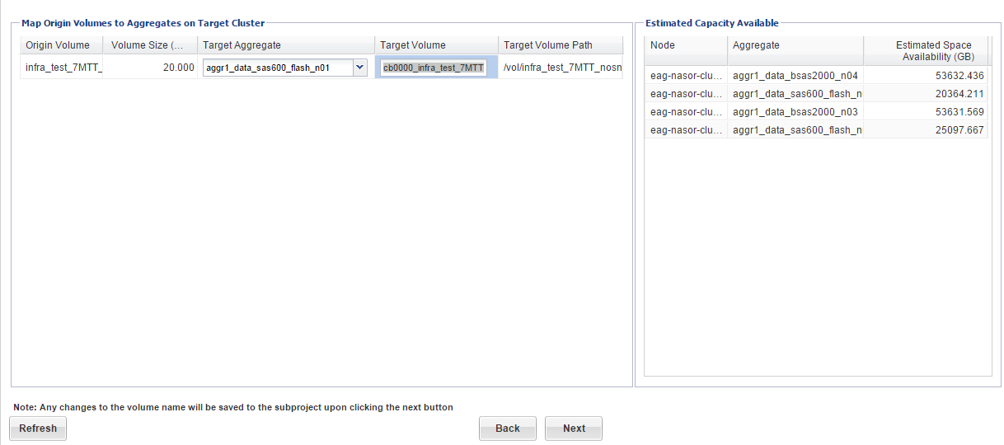

## Interface Mapping

The tool affords the administrator the opportunity to also map 7-Mode IP addresses to Cluster LIFs. At this time there are no TR use cases for migrating 7 mode vfilers. If a need is identified this section of the document will be updated.

Click next

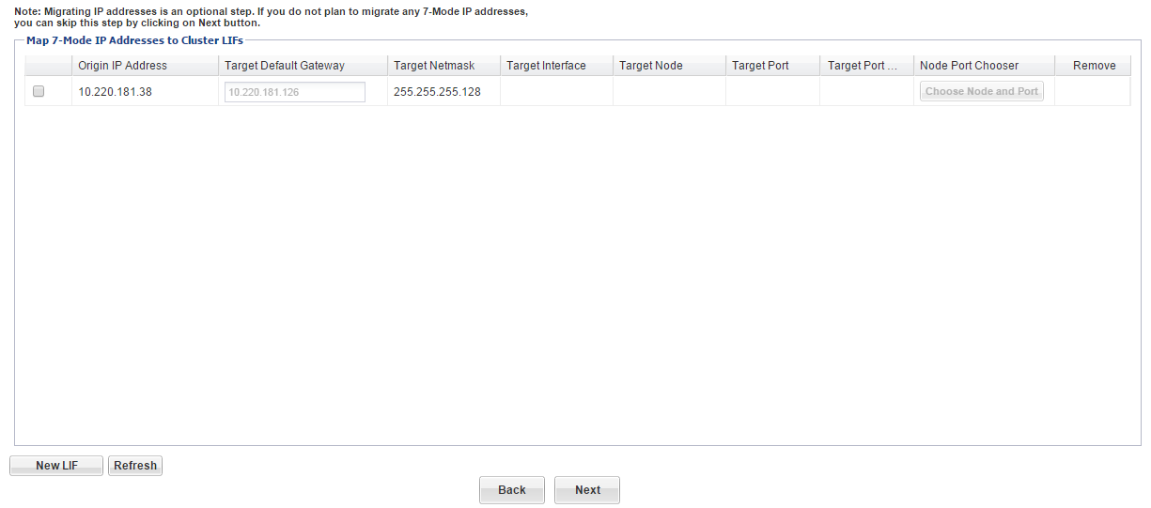

## Data Copy Schedule

This portion of the tool allows the administrator to enforce a schedule for the migration activity. There are a few considerations when scheduling subprojects.

* The administrator should ensure data copy schedules do no overlap across different subprojects if the projects are utilizing the same resources.
* Ensuring data copy schedules do not overlap with DP activities, this is to say data copy schedules should not align with TR snapvault activity.
* Configure the number of concurrent transfers in a fashion so that existing 7-Mode SnapVault schedules do not fail.
* The administrator should ensure the throttle is configured so that operations will not fail and do not interfere with filer performance.

Click Create Schedule.

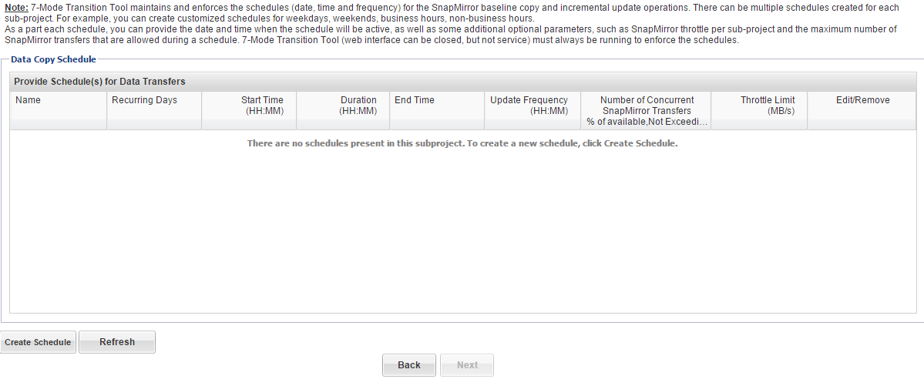

Enter desired parameters, click create.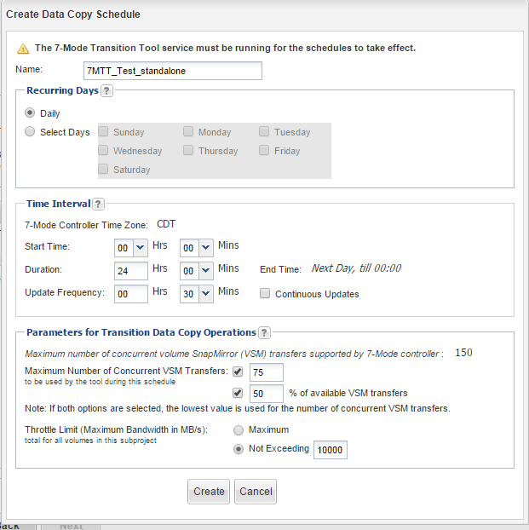

Click Next.

## Final Prechecks

This is a final check to migration configuration. The administrator should check there are no error messages before proceeding to the next step.

Click Run Prechecks, after verification click next.

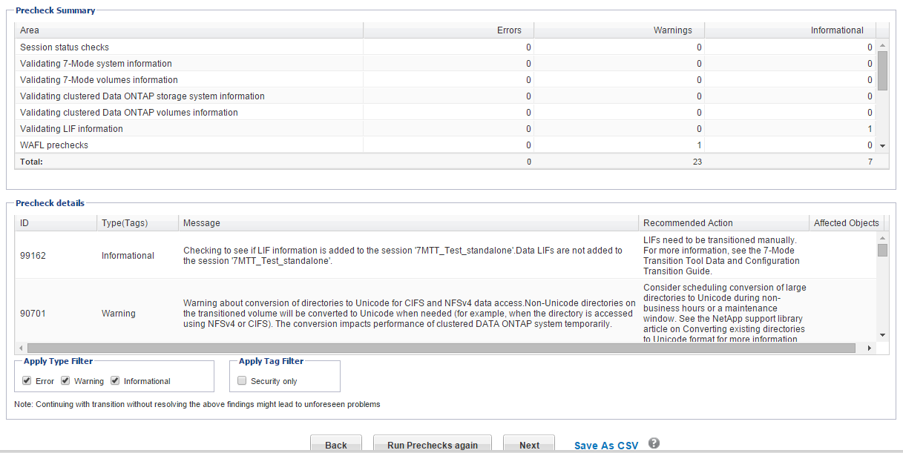

## Subproject Summary

The administrator should be diligent in reviewing the migration summary and make any necessary changes before proceeding to the 7MTT dashboard.

Click Save and go to Dashboard.

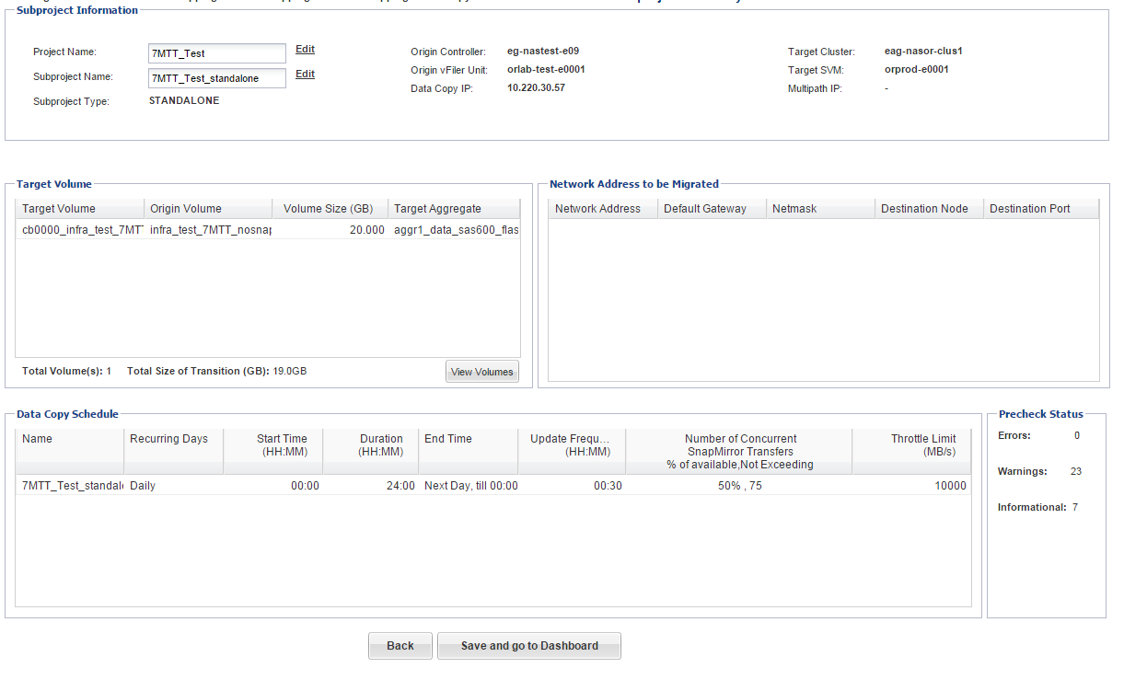

# Migration Activity

## Start Baseline

Click Start Baseline

The tool will go through a number of phases when starting the baseline. The first is a run through of the prechecks, it will remind the administrator to review the warnings populated during the system precheck. If confident the warnings will not have an adverse on migration click continue anyway when the system displays error message

The system will then start to the baseline copy. The administrator will know this is in progress while the marker is yellow.

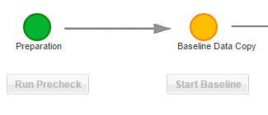.

Transition details can also be viewed by clicking the View Transition Details in the volumes tab.

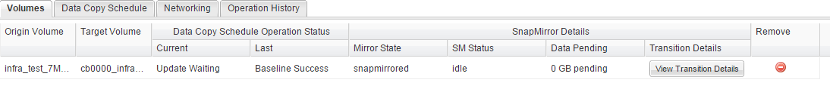

## Apply Configuration

Click Apply Configuration, this will apply the configuration details specified in sections 3.5-3.7. The administrator has the opportunity to test the configuration before executing this step. Testing places the cDOT volumes in R/W mode. It should be noted here that the junction path applied by the system is incorrect and will need to be modified to reflect the volume name. See post migration steps.

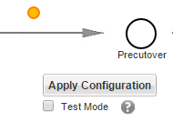

Click continue unless, further data schedule customization is needed.

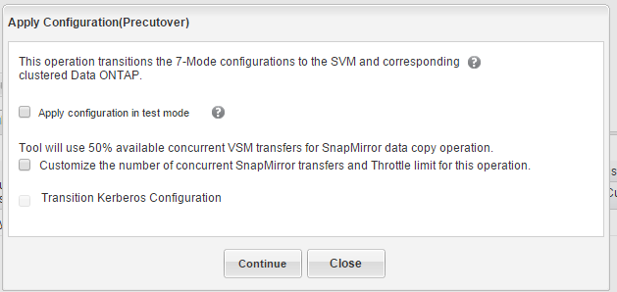

System completes another round of checks, view log and confirm there are no errors which will affect the final cutover.

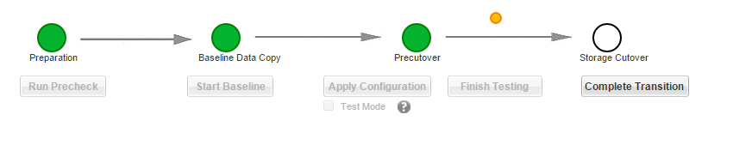

## Complete Transition

Click complete Tranistion.

The system alerts the administrator to address all warnings before performing cutover operation. Click yes to continue.

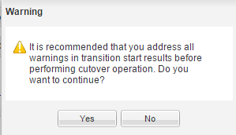

Completing the transition makes the origin volumes offline, which is a disruptive operation. The administrator should be sure there is no additional traffic to the volumes which are being transitioned. Click continue.

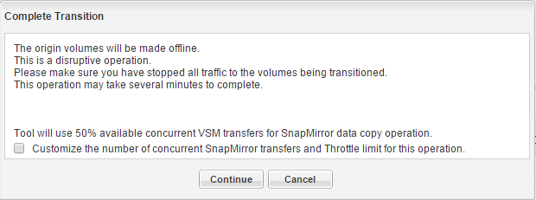.

The migration activity is complete once the Storage Cutover bubble has turned green.

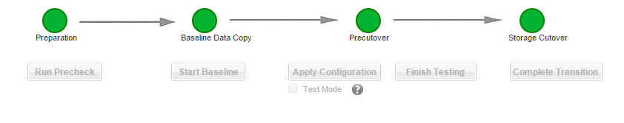

# Post Migration Activity

## Checks

The following elements of the new cDOT volume should be checked and modified as needed.

1. Volume Options – Check to make sure the volume options are consistent with cDOT volume standards.

-vol show –volume <volume name> -instance

1. Export-Policy - The 7MTT does not transition export definitions between the vfilers and the new VSM. The administrator will need to define a new export policy and apply it to the cDOT volume.

export-policy create -vserver <vserver> -policyname <policy name>

vol modify -volume <volume> -vserver <vserver> -policy <policyname>

1. Export-Policy Rules- The rules for both the vserver default export policy as well as the specific volume policy created in step 2, need to be updated to include the appropriate clients and necessary permissions.

Export-policy rule create –vserver <vserver> -policyname <policy name> -clientmatch <fqdn or ip address of server> -rorule</any/none/krb5/ntlm/sys> -rwrule</any/none/krb5/ntlm/sys> -superuser</any/none/krb5/ntlm/sys>

1. Junction Path – The transition tool retains the original 7 mode volume mount point during the migration. This needs to be redefined as the new cDOT volume name.

vol unmount –vserver<vserver> -volume<volume>

vol mount –vserver<vserver> -volume<volume> -junction-path</volname>

vol show –volume<volume> -fields junction-path

1. Qos Policy – No QoS policy will exist for the new cDOT volume. The administrator will need to define a qos policy for the volume consistent with TR standards. <ref volume standard doc>